Authentic Novel List

COVER | GRADE | TITLE/INFO
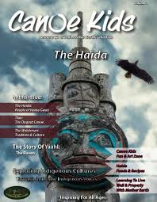 | K-12 | Canoe Kids  This Canadian magazine-style resource has a number of illustrated short articles providing historical, environmental, and cultural information about the Haida Nation. Suitable for grades K-12, it offers many uses in the classroom: articles could promote discussion and prompt journal writing, images and personal narratives provide a starting point for inquiry-based learning, and its culturally rich stories, history, and imagery make it a useful supplementary resource. The resource offers book reviews, an accompanying online resource, and movie and documentary suggestions that could be used for higher-level, critical thinking discussions and activities.
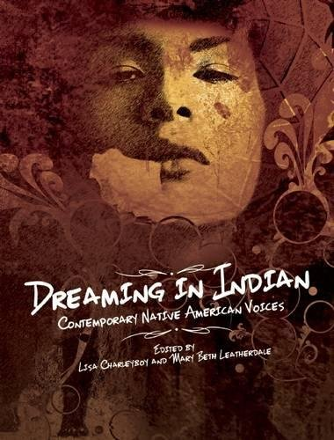 | K-12 | Dreaming in Indian by Lisa Charleyboy  This is a highly engaging, visually rich and representative sample of Aboriginal voice from all over North America. It is an excellent fit with the expectation that aboriginal perspectives be integrated into the curriculum
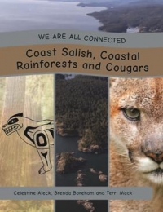 | K-12 | We are all Connected Series  We Are All Connected is a series that explores how we all live together in a shared balance upon Mother Earth. Each book explores a specific ecosystem with a focus on one animal and its adaptations for survival within that ecosystem. Indigenous interviewees, each living within the same area, have responded to strategic questions as to how their community interacts with the land, their traditional territory. Explore each text with a sense of inquiry in mind.
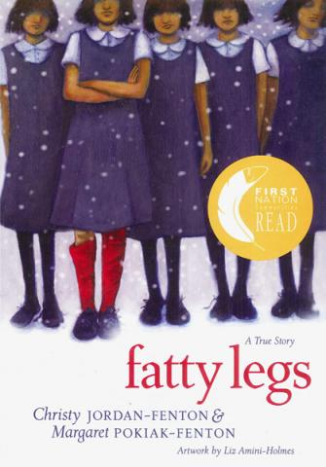 | 3-7 | Fatty Legs: A True Story by Christy Jordan-Fenton and Margaret Pokiak-Fenton  A recounting of the life of an eight-year-old Banks Island Inuvialuit girl who attended Residential School. Olemaun Pokiak, later called Margaret, tells her story in this memoir. In the introduction she explains the book's title, Fatty Legs, is the result of her destruction of the dreaded red-coloured stockings a nun forced her to wear at residential school. The picture book tells about her life before residential school, how she travelled five days to attend the school, and her life at the school. It turned out the school was much different from the place she imagined. Despite bullying from other girls attending the school and the racism of the school teachers, Margaret succeeds and learns to read. She enjoys reading and vows not to let the teachers and other classmates bully her.  Lesson Plan: http://www.annickpress.com/Fatty-Legs
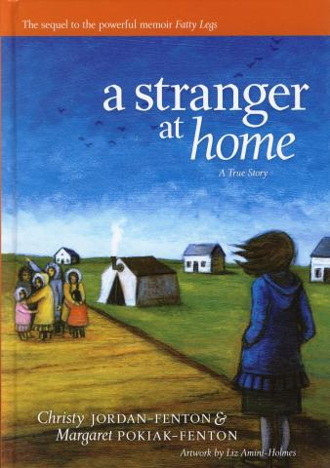 | 3-7 | A Stranger at Home by Christy Jordan-Fenton and Margaret Pokiak-Fenton  The sequel to the novel Fatty Legs. This 124-illustrated chapter book joins Margaret upon her return to her family from spending two years at residential school. Margaret is full of anticipation and joy but suddenly comes to grips with the fact that her mother no longer recognizes her ten-year old daughter with short hair and looking taller and thinner. This initial reluctance by her mother is countered by the loving embrace from her father. But Margaret realizes she has changed forever because she no longer remembers her Inuvialuit language, turns up her nose at her mother's country food, and finds her residential school clothes more comfortable than her Inuit-style clothing. Even her best friend Agnes was prevented from playing with Margaret because the community felt that Margaret was now a bad influence as an outsider. Margaret slowly regains her parents love and understanding as her mother asks for reading and writing lessons and Margaret receives her own dog team and sled to care for. When the time comes for Margaret's younger sisters to attend residential school Margaret is asked to perform her most difficult challenge by returning to the place that made her an outsider in her own community. Reading Level: 5.5 Guided Reading Level: U.  For a lesson plan see http://www.bookrapport.com/images/pdfs/2011/lessonplanfentons2.pdf
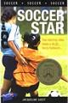 | 4-7 | Soccer Star by Jacqueline Guest  A title in the Lorimer series, Sports Stories. Samantha Aqsarniq Keyes is used to a life on the move. Her military family has been transferred across Canada, and she's grown up with stories of her Inuit ancestors exploring the far north. For Sam, soccer has been the one constant in her life. But now that she's thirteen, her home base isn't the only thing that's changing. Sam longs to show up Carly, her school's reigning soccer star, but Sam's new interest in theater is taking up a lot of time. Does she have the time to practice her sport and be the lead in the school play? And just how far will she go to prove to her parents that she can handle more than one extracurricular activity? Soccer Star! is a novel about big ambitions and tough choices. Reading Level: 4.9; Fry Reading Level - 4.7. FNCR 2013
 | 4-7 | Triple Threat by Jacqueline Guest  Features a basketball theme alongside a blended family, and the sport of wheelchair basketball. The main character is Matt Eagletail, a 13-year-old First Nation boy, who lives in Calgary with his mother, and stepfather, who is white, and his five stepsisters. Matt spends his time on the court and online with his friend Free Throw, who is a wheelchair athlete who coaches basketball. The pair meets one summer and together they build a basketball team of neighbourhood boys and girls. The storyline features bullying, discrimination against wheelchair athletes and girls, racism, and tolerance. Ideal for students interested in sports; grades four to eight. 2012 American Indian Youth Literature Award Winner. Reading Level: 5.0; ATOS Reading Level: 5.5. Intermediate Spring 2012. FNCR 2013
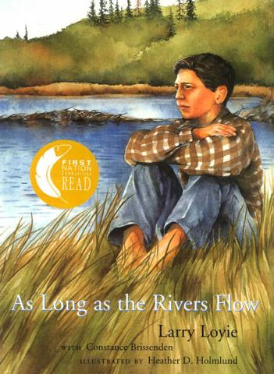 | 4-7 | As Long as the Rivers Flow by Larry Loyie  Starting in the 1800s and continuing into the 20th century, First Nations children were forcibly taken to government sponsored residential schools to erase their traditional languages and cultures. This moving book tells of one such child, author Larry Loyie, and his last summer with his Cree tribe. It is a time of learning and adventure. He cares for an abandoned baby owl, watches his grandmother make winter moccasins, and sees her kill a huge grizzly with one shot. The sensitive text and Heather Holmlund's expressive illustrations beautifully capture the joy and drama of a First Nations family's last summer together.
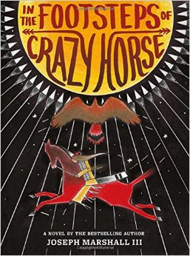 | 4-8 | In the Footsteps of Crazy Horse by Joseph Marshall III Abrams  Bullied by classmates about his light coloring, an 11-year-old Lakota boy embarks on a road trip with his storyteller grandfather to learn about his heritage—and himself—by visiting landmarks linked to the great 19th-century Lakota leader. A vividly told, emotionally multifaceted, and eye-opening journey into American history.
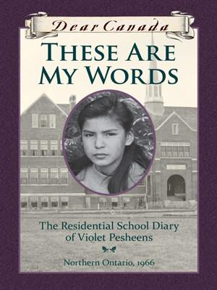 | 4-8  FR | Dear Canada: These are My Words, The Residential School Diary of Violet Pasheens, Northern Ontario 1966  by Ruby Slipperjack  The 200-page fictional diary presents the perspective of an Ojibwe girl who is forced to attend a residential school in 1966. Violet has to leave her loving home living with her grandma and attend a foreign institution run by nuns who insist on only speaking English and attending chapel daily. Dealing with number instead her name, Violet finds life challenging as she experiences a haircut and brutal delousing despite the lack of lice in her long hair, living in a dormitory much like a military barracks she once saw in a book's picture, all the girls wore the same uniform, and extreme loneliness. Food was a strange new world for the children who often went to bed hungry. One part-time staff person is the only friendly face among the adults. Ruby Slipperjack inserts some of her personal experiences and feelings based on her early years attending a residential school. A unique feature of this story about these schools involves the body changes of adolescent girls is addressed in this account. On the whole this account is a welcome addition to the residential school narratives especially for grades 5 to intermediate levels. Highly Recommended. Discussion Guide: http://www.scholastic.ca/dearcanada/teaching/pdfs/TheseAreMyWords.pdf
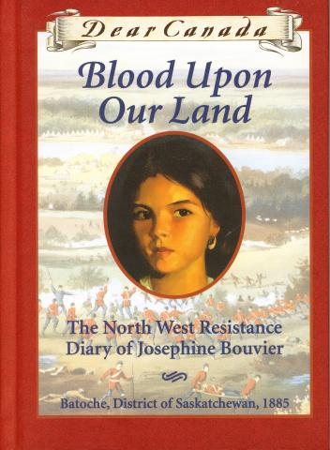 | 4-8  FR | Dear Canada Blood Upon Our Land: The North West Resistance Diary of Josephine Bouvier  by Maxine Trottier  Dear Canada Series. Text in English, with some French words. Thirteen-year-old Josephine describes, in journal format, her mixed feelings about the North West Resistance against the white settlers in the late nineteenth century as the Métis and allied First Nations fight for their way of life in Canada. Tension grips Batoche, Saskatchewan in 1885. Many Métis have moved here after the 1870 Riel Rebellion in Manitoba. But life in Batoche is difficult. The Métis seem to be losing their way of life. They want title to their land, but the government has delayed it for years, and talk of a second uprising is in the air. Thirteen-year-old Josephine finds herself torn over the Resistance: she is worried for her brother who is eager to fight; for her father who prefers a peaceful solution; and for Louis Riel, the leader whose is trying to preserve the Métis way of life. Will her community be able to survive this unrest? ATOS Reading Level: 5.9; Reading Level: 6.3  Publisher Discussion Guide available at: http://www.scholastic.ca/dearcanada/teaching/pdfs/Blooduponourland.pdf
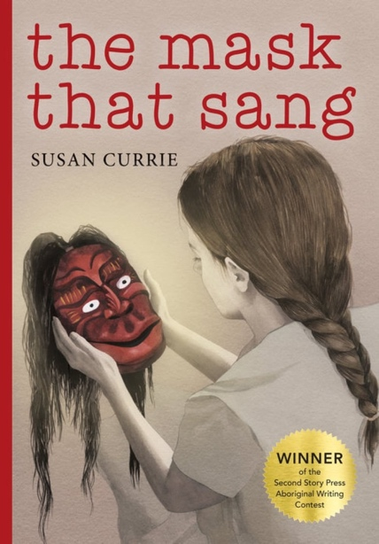 | 4-9 | The Mask that Sang by Susan Currie  Cass and her mom have always stood on their own against the world. Then Cass learns she had a grandmother, one who was never part of her life, one who has just died and left her and her mother the first house they could call their own. But with it comes more questions than answers: Why is her Mom so determined not to live there? Why was this relative kept so secret? And what is the unusual mask, forgotten in a drawer, trying to tell her? Strange dreams, strange voices, and strange incidents all lead Cass closer to solving the mystery and making connections she never dreamed she had.
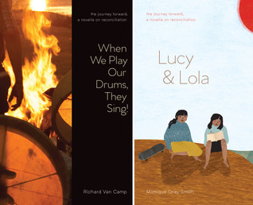 | 4-9 | When We Play Our Drums, They Sing! Lisa and Lola  By Richard Van Camp and Monique Gray Smith  This collection of two novellas focuses on Indigenous children who learn about their roots, culture, love, and reconciliation through the teachings of elders and family members. The stories present past and present struggles and stereotypes that Indigenous people face and demonstrate how past events affect Indigenous youth today and have an impact on their sense of self and culture. Suitable for grades 4-11, this resource would be useful as a read-aloud or literature circle selection for units on residential schools and Indigenous culture and to launch discussion and pair with a drum-making session or a visit from an Indigenous elder.
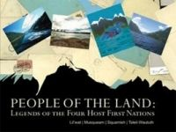 | 4-12 | People of the Land Legends from our Four Host Nations  The sacred legends of the four host First Nations, the Lil’wat, Musqueam, Squamish, and Tsleil-Waututh, have been passed down from generation to generation through the Elders and are integral to the teachings and oral traditions of First Nations peoples. These stories link people to the land and to each other.
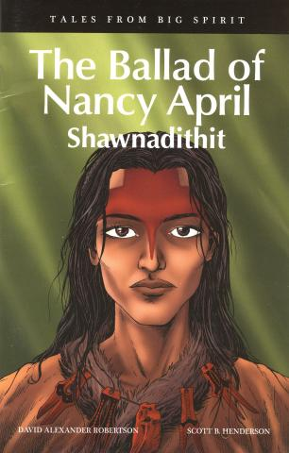 | GN  4-12  FR | Tales from Big Spirit is a unique six-book graphic novel series that delves into the stories of six great Indigenous heroes from Aboriginal peoples and Canadian history—some already well known and others who deserve to be. Designed to correspond to grades 4–6 social studies curriculums across Canada, these full colour graphic novels could be used in literature circles, novel studies, and book clubs to facilitate discussion of social studies topics.
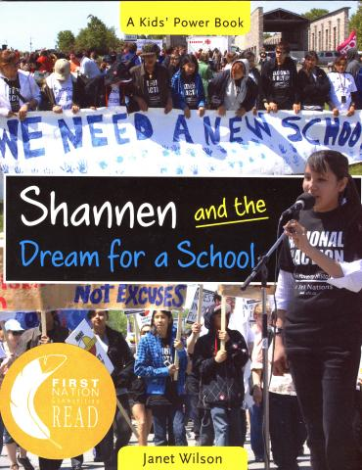 | 5+ | Shannen and the Dream for a School by Janet Wilson  Shannen and the Dream for a School is one of the titles in the Kids Power Series from Second Story Press. The author has taken the real-life story of Shannen Koostachin, her friends and family of Attawapiskat and created a fictionalized account in a chapter book format. Shannen was a student attending JR Nakogee Elementary when her and other community students began a campaign to have a new school built. The school had been contaminated by a fuel spill in 1979, and now students were forced to endure moldy and drafty portables during the school day. At thirteen Shannen and her classmates created a YouTube video about their school portables’ conditions and how they all wanted a safe and healthy building in which to learn. The video turned viral and garnered support from a variety of students across Canada as well as support from organizations. The author successfully weaves created dialogue into this fictionalized story but remains faithful to the heart of this moving story. Portraying a history of this James Bay Cree community's 30-year efforts to lobby for a decent school building as well as explaining the history of the Indian Act and the role of the federal government in the lives of First Nations is accomplished with ease and simplicity. In addition the book includes black and white photographs of Shannen and her classmates and family as well as a timeline, glossary and map. The role of a thirteen-year-old Cree activist is told with respect and dignity. Shannon's dream of a new school for Attawapiskat was unrealized when she tragically died in an automobile accident when she was fifteen. Despite the loss of this bright and determined student her dream for a safe and healthy learning environment for all First Nations students has been kept alive by her friends and family and we all look forward to the day in the near future when a new school at Attawapiskat is opened. ATOS Reading Level: 5.9; Lexile Measure: 840; Reading Level: 5.5. Highly recommended. Shannen and the Dream for a School is the Selected Title for First Nation Communities Read 2012-2013 program. Janet Wilson's Teacher Guide is located at: http://www.janetwilson.ca/study-guide-shannen-and-the-dream-for-a-school.html
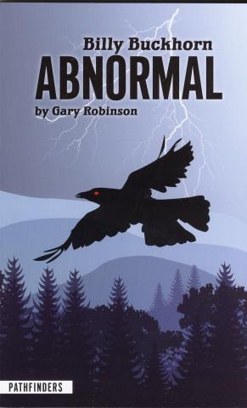 | 5+ | Billy Buckhorn: Abnormal by Gary Robinson  The first in a three-book series introduces Cherokee youth Billy Buckhorn, whose uncanny intuition became apparent at an early age. Billy begins to experience an enhanced level of ESP after he survives being struck by lightning. This sudden increase in power puts Billy at odds with a teacher who labels him "abnormal". Billy soon uncovers an unsavory secret from the teacher's past, and uses his psychic power to expose the teacher's true motives and stop his diabolical plan. PathFinders hi/low novels are written at a lower reading level but with age-appropriate plots. The main characters in all the titles are Native American teens and the stories all include references to traditional ways. These books feature an easy-to-read layout, linear story lines, limited vocabulary and contemporary as well as historic topics. Reading Level 4.2
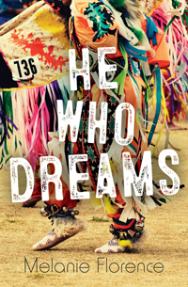 | 5-7 | He Who Dreams by Melanie Florence  Juggling soccer, school, friends and family leaves John with little time for anything else. But one day at the local community center, following the sound of drums, he stumbles into an Indigenous dance class. Before he knows what's happening, John finds himself stumbling through beginner classes with a bunch of little girls, skipping soccer practice and letting his other responsibilities slide. When he attends a pow wow and witnesses a powerful performance, he realizes that he wants to be a dancer more than anything. But the nearest class for boys is at the Native Cultural Center in the city, and he still hasn't told his family or friends about his new passion. If he wants to dance, he will have to stop hiding. Between the mocking of his teammates and the hostility of the boys in his dance class, John must find a way to balance and embrace both the Irish and Cree sides of his heritage.
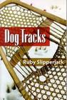 | 5-7 | Dog Tracks: A Novel by Ruby Slipperjack  A recent work by Ojibwe writer and educator. In this young adult novel, a thirteen-year-old girl of mixed heritage is thrust into a new situation when she leaves her familiar home in a small town and returns to her mother's First Nation. Gone is the pink bedroom, left behind are her grandparents, friends and classmates as Abby struggles to make new friends and fit into the reserve community. It is a place she found to be boring on her previous brief visits. Her mother has a new husband and Abby finds she has a half-brother that makes fitting in more challenging. But Abby draws on the Ojibwe teachings of her grandparents and her own strength of character to make a place of her own. The new family is planning a business venture with a sled-dog and tourism plan that interests Abby when a puppy becomes part of her family. Throughout this highly readable novel, the author seamlessly weaves information about traditional and contemporary Ojibwe lifestyles. Based on her own childhood upbringing Slipperjack offers readers an enjoyable and moving experience of a First Nations teen that finds her identity and begins to find a true home once again. The book includes a helpful map of the Bear Creek community and identifies homes of Abby's family, friends, and community public buildings.
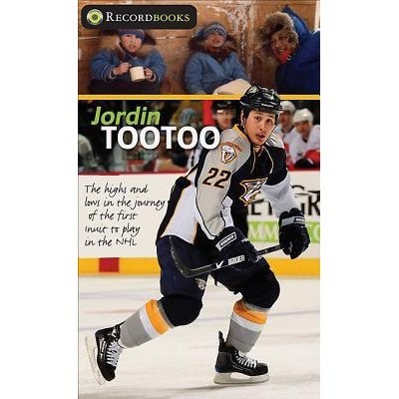 | 5-9 | Jordin Tootoo: The Highs and Lows in the Journey of the First Inuit to Play in the NHL by Melanie Florence  A young adult novel from the Record Books Series from James Lorimer Publishers. This high interest and low vocabulary title is aimed at reluctant teen readers whose reading is at a grades 3 and 4 level. Jordin Tootoo is the first Inuk to join a NHL hockey team. His brother's suicide is discussed as one of the challenges he has faced along with some of his successes as a young man and a major hokey player. The biography has short chapters and is an easy to read story about a current sports figure who continues to overcome challenges while establishing his credibility as a role model for Aboriginal youth.
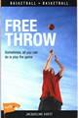 | 5-9 | Free Throw by Jacqueline Guest  A basketball themed novel. In this story a Blackfoot youth is on a winning basketball team at his on-reserve school. Next comes great changes for he and his mother following her marriage to a non-Aboriginal man. The blended families must learn to live together as stepbrother and sister. But the Blackfoot youth finds that made more challenging after his mother moves to the city to live with the new husband's family. The boy must move in mid-season and must find the courage to face adjusting to an urban school and a new basketball team.
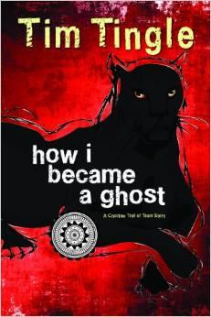 | 5-9 | How I Became a Ghost: A Choctaw Trail of Tears Story  by Tim Tingle  This story approaches the topic of the Choctaw removal process from Mississippi homeland to the Oklahoma Reservation during the 1800s through the eyes of a 10-year-old boy. Winner of the 2014 American Indian Youth Literature Award.
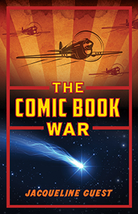 | 5-9 | Comic Book War by Jacqueline Guest  It’s 1943 and World War II is raging. 15-year-old Robert Tourond is safe at home in Calgary, but his three brothers are all overseas, fighting the Nazis. A dreamer, Robert closely follows the exploits of his three favourite comic book heroes – Captain Ice, Sedna of the Sea and the Maple Leaf Kid – who also battle the bad guys in the monthly comics he spends his allowance on.  Lesson ideas:  https://www.jacquelineguest.com/wp-content/uploads/2014/10/CBW-StudyGuide.pdf
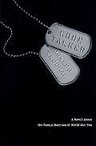 | 5-9 | Code Talker by Joseph Bruchac  Throughout World War II, in the conflict fought against Japan, Navajo code talkers were a crucial part of the U.S. effort, sending messages back and forth in an unbreakable code that used their native language. They braved some of the heaviest fighting of the war, and with their code, they saved countless American lives. Yet their story remained classified for more than twenty years.  But now Joseph Bruchac brings their stories to life for young adults through the riveting fictional tale of Ned Begay, a sixteen year old Navajo boy who becomes a code talker. His grueling journey is eye opening and inspiring. This deeply affecting novel honors all of those young men, like Ned, who dared to serve, and it honors the culture and language of the Navajo Indians.
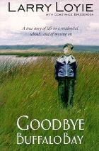 | 5-10 | Goodbye Buffalo Bay by Larry Loyie  Goodbye Buffalo Bay is set during the author's teenaged years. In his last year in residential school, Lawrence learns the power of friendship and finds the courage to stand up for his beliefs. He returns home to find the traditional First Nations life he loved is over. He feels like a stranger to his family until his grandfather's gentle guidance helps him find his way. New adventures arise; Lawrence fights a terrifying forest fire, makes his first non-Native friends, stands up for himself in the harsh conditions of a sawmill, meets his first sweetheart and fulfills his dream of living in the mountains. Wearing new ice skates bought with his hard-won wages, Lawrence discovers a sense of freedom and self-esteem. Goodbye Buffalo Bay explores the themes of self-discovery, the importance of friendship, the difference between anger and assertiveness and the realization of youthful dreams.
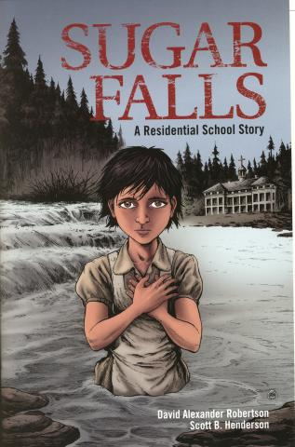 | GN  6-12 | Sugar Falls: A Residential School Story by David Alexander Robertson  BASED ON A TRUE STORY* A school assignment to interview a residential school survivor leads Daniel to Betsy, his friend's grandmother, who tells him her story. Abandoned as a young child, Betsy was soon adopted into a loving family. A few short years later, at the age of 8, everything changed. Betsy was taken away to a residential school. There she was forced to endure abuse and indignity, but Betsy recalled the words her father spoke to her at Sugar Falls words that gave her the resilience, strength, and determination
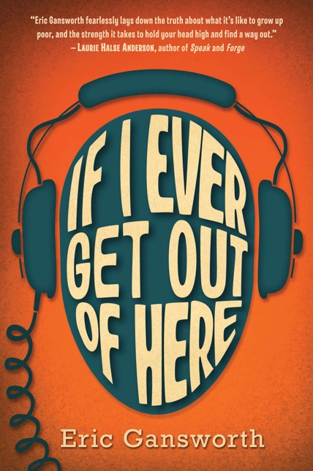 | 6-9 | If I Ever Get Out of Here by Eric Gansworth  Lewis "Shoe" Blake is used to the joys and difficulties of life on the Tuscarora Indian reservation in 1975: the joking, the Fireball games, the snow blowing through his roof. What he's not used to is white people being nice to him -- people like George Haddonfield, whose family recently moved to town with the Air Force. As the boys connect through their mutual passion for music, especially the Beatles, Lewis has to lie more and more to hide the reality of his family's poverty from George. He also has to deal with the vicious Evan Reininger, who makes Lewis the special target of his wrath. But when everyone else is on Evan's side, how can he be defeated? And if George finds out the truth about Lewis's home -- will he still be his friend?
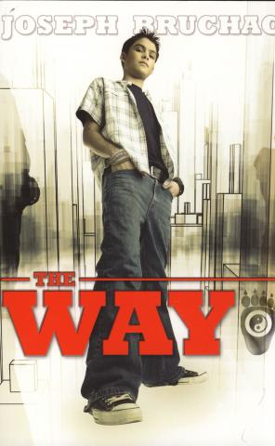 | 6-9 | The Way by Joseph Bruchac  A 2007 young-adult novel featuring an Abenaki youth dealing with teasing and bullying. In this story Cody is just beginning his high school career and deals with bullies through his imagination and trying to remain invisible to those who target weak students. Cody has a tendency to stutter and this makes him more self-conscience. In his imagination Cody is a super ninja hero who saves the students around him and is praised at his funeral. But on the day-to-day school front, Cody and other students have to try not to be the victims. Just when all looks bleak an unexpected visit of the uncle he never knew existed comes to stay at Cody's house. Growing up without his father present Cody is in need of a male role model and Uncle John meets the challenge. As a martial arts competitor Uncle John begins to teach Cody the way. It is not the way of the fist but practice and philosophy of martial arts shows Cody how everything is connected and leads to his growing confidence. The technique and teachings empower Cody to use his mind rather than brute strength to deal with a serious bullying situation at school.  Reading Level: 7; Lexile Level: Level: 850L; Reading Counts: Level: 5.5.
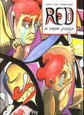 | GN  7+ | Red: A Haida Manga by Michael Nicoll Yahgulanaas.  Combining the art styles of Haida carvers and the graphic aspects of Japanese manga, Yahgulanaas creates a captivating and innovative graphic novel that retells a Haida narrative for a contemporary audience. The main character is Red, an orphan, who experiences tragic loss when his sister Jaada is kidnapped from their village. The boy seethes with rage and revenge grips his soul. When Red becomes a leader he acts on his rage and leads his village into war and near destruction. Red locates his sister and learns that war and revenge is not the answer for loss and grief. The book consists of 108 pages of hand-painted illustrations that can be recombined to create a Haida formline image 4 meters long. This image can be seen on the inside of the jacket flap. Michael Nicoll Yahgulanaas (1954- ) is from Delkatla in Masset on Haida Gwaii and has exhibited in Japan, Korea, England, and Canada. He is a descendant of Charles Edenshaw and a relative of Robert Davidson. This book is a work of art and should be a popular graphic novel for senior elementary and secondary students. Highly recommended. Reading Level: 5.  Author's Homepage: http://mny.ca/en/index.html  Review of Red: http://graphicallyinclined.wordpress.com/2010/02/.  Myth and Manga: http://www.mythandmanga.com/2010/02/influences-in-manga-red-haida-manga....
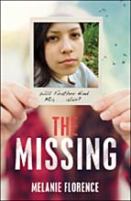 | 7+ | The Missing by Melanie Florence  This book uses as its background the ongoing circumstance of unsolved cases of missing and murdered Aboriginal women and girls, this fictional mystery set in Winnipeg explores one teenager's response to a system that has long denied and misrepresented the problem. After a girl she knows from school goes missing and is found dead in the Red River, Feather is shocked when the police write it off as a suicide. Then, it's Feather's best friend, Mia, who vanishes — but Mia's mom and abusive stepfather paint Mia as a frequent runaway, so the authorities won't investigate her disappearance either. Everyone knows that Native girls are disappearing and being killed, but no one is connecting the dots. When Feather's brother Kiowa is arrested under suspicion of Mia's abduction, Feather knows she has to clear his name. What Feather doesn't know is that the young serial killer who has taken Mia has become obsessed with Feather, and her investigation is leading her into terrible danger.
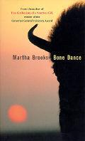 | 7+ | Bone Dance by Martha Brooks  Now in its fourth printing. The story is set in Manitoba and tells the interwoven story of two teens struggling with identity, self-esteem, and most of all loss. Written in third person, past tense the story line follows the parallel lives of two eighteen-year-olds. Alexander and Lonny have both lost a parent and are haunted by waking dreams. Lonny had disturbed a burial mound when he was twelve and that act, he believes, precipitated the death of his mother. Alex's character loses her alcoholic father she knows only through six letters from childhood. Then Alex's father wills her land with a lake and cabin. She decides to visit this property and finds Lonny wondering why this city interloper is claiming his stepfather's land. But after several meetings the two find that their spiritual guides have been drawing their lives together. An interesting approach to teen loss and guilt in this novel that draws on spiritual teachings from First Nations Elders that permits healing.
 | 7-9 | Arctic Thunder : a Novel by Robert Feagan  Mike Watson’s team has just won the Alberta Bantam Provincial box lacrosse championships. The euphoria of victory and plans for next season are short-lived when Mike’s father, a member of the Royal Canadian Mounted Police, is transferred to Inuvik, Northwest Territories.  The transition to life inside the Arctic Circle is a tough one. With temperatures of -30 Celsius, a hulking monster named Joseph Kiktorak threatening him at every turn, and not a lacrosse ball in site, Mike’s resentment at moving north escalates.  As his friendships with local youth develop, Mike is introduced to the amazing spectacle and athleticism of traditional "Arctic Sports." When his father witnesses the natural talent of Mike’s new friends, the idea of an Inuvik lacrosse team is born! With hearts full of desire, the motley group of athletes heads south to participate in the Baggataway Lacrosse Tournament, and to face Mike’s former team, The Rams.
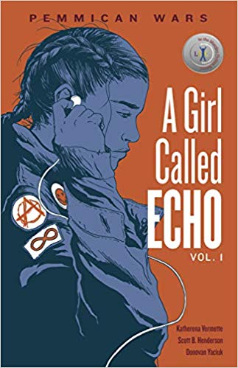 | 7-9 | A Girl Called Echo, Vol 1: Pemmican Wars by Kathrena Vermette  This compelling graphic novel opens with 13-year-old Echo overlooking the Qu’Appelle Valley in 1814, shocked at seeing tipis, historically dressed people, and a bison hunt, then abruptly is transported back to the modern world. Echo is new to her school and her foster home, feels isolated, and searches for her identity and belonging; her trips back in time, where she learns about her Metis ancestry and the Pemmican Wars, moderate these feelings. The novel uses storytelling with limited text and detailed images to relate historical and contemporary Metis experiences. Suitable for lit circles, as a reference about Metis history and culture, and as a model of storytelling through the visual arts.
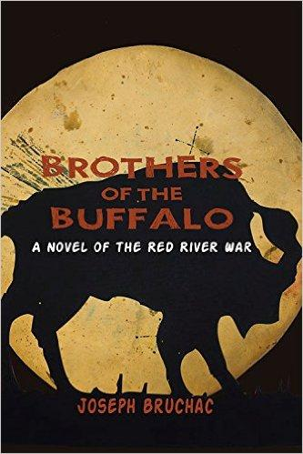 | 7+ | Brothers of the Buffalo by Joseph Bruchac  In Brothers of the Buffalo by Abenaki storyteller and internationally acclaimed writer, Joseph Bruchac, explores the battles of the Red River War from the perspective of both a former Black slave turned U.S. cavalryman and a Cheyenne warrior. In 1874, the U.S. Army sent troops to subdue and move the Nations of the southern plains to reservations and this young adult novel chronicles the brief and brutal war that followed. Told from the viewpoint of two youths from opposite sides of the fight, Brothers of the Buffalo portrays the events surrounding this conflict in the American west.
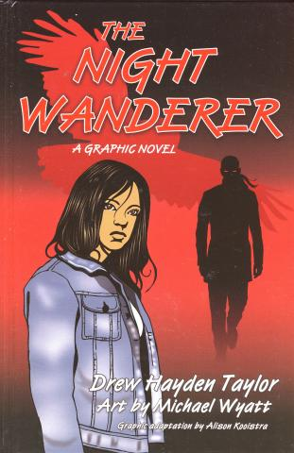 | GN  7+  Also a novel | The Night Wanderer: A Graphic Novel by Drew Hayden Taylor (Adapted by Alison Kooistra)  This graphic novel takes the main characters from the novel and adapts them to comic book format. Teenager Tiffany Hunter is a disgruntled high school student who lives with her dysfunctional family on a small Ojibwe reserve. Otter Lake is her home and living at her house are her father and his mother. Grandmother is caring and wise and holds the family together after Tiffany's mother left her family for another man. Both father and daughter are grieving in their own way and into this mix a mysterious Ojibwe man who claims he is from Europe arrives looking for a guest room. Pierre L'Errant has wandered for generations far from his home village that he last saw when he was an adventurous youth who long ago joined a fur-laden canoe of traders. Over the years Pierre has lived several lifetimes and now returns to his homeland on a special quest. Living in the Hunter basement because of his odd hours, Pierre searches the woods around the reserve every nighttime. Meanwhile Tiffany is having serious issues with her white boyfriend as well as her father. Together the teen and the mysterious man from Europe spend an eventful night by the lake as each grapple with enormous, life-changing issues. Taylor has created a graphic novel thriller with an Ojibwe twist that draws on themes of family, relationships, redemption, traditional values, dealing with prejudice, and spiritual growth. Recommended. A paper edition of The Night Wanderer: A Graphic Novel is also available. Fountas and Pinnell Reading Level: Z
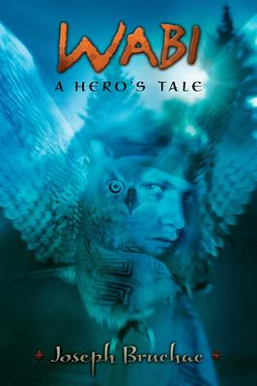 | 7-9 | Wabi : a Hero's Tale By Joseph Bruchac  Wabi was born a great horned owl who grew to become such a strong, confident creature that he was afraid of nothing. But now he is afraid. He fears that he might never win the heart of the girl he loves. Somehow, despite his own intentions, he has fallen in love with a girl – a beautiful, headstrong human girl. And so he begins the adventure of his life. But before he can win her love, he must face an even greater challenge in a land he comes to think as the Valley of Monsters.
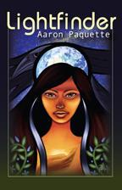 | 7-10 | Lightfinder by Aaron Paquette.  A young adult fantasy novel about Aisling, a young Cree woman who sets out into the wilderness with her Kokum (grandmother), Aunty and two young men she barely knows. They have to find and rescue her runaway younger brother, Eric. Along the way she learns that the legends of her people might be real and that she has a growing power of her own. The story follows the paths of Aisling and Eric, siblings unwittingly thrust into a millennia old struggle for the future of life on earth. It deals with growing up, love and loss, and the choices life puts in our path. Love and confusion are in store, as are loss and pain. Things are not always what they seem and danger surrounds them at every turn. Will Raven's mysterious purposes prevail? With darkness closing in how will they find the light to guide them? Will Aisling find Eric in time? Black and white illustrations along with short chapters aid young adult readers comprehension and enjoyment of this page-turner.
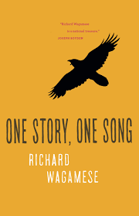 | 7-12 | One Story, One Song by Richard Wagamese  This autobiographical work, by Canadian Indigenous author Richard Wagamese, is a collection of vignettes reflecting his life lessons, messages, and values. The stories provide lessons of hope, humility, strength, grit, and resilience, and he invites readers to contemplate their interactions and interconnectedness with people, animals, and the Earth. This work, for grades 7-12, sheds light on situations that will help students develop greater understanding and empathy for others. Written using clear and common language, it could be a useful novel study or for a class read while discussing or responding to the topics and teachings found in each chapter.
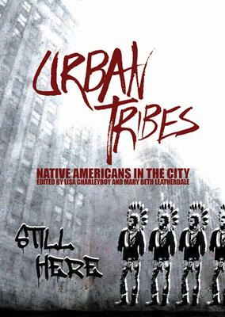 | 7-12 | Urban Tribes: Native Americans in the City by Lisa Charleyboy  Urban Tribes offers unique insight into this growing and often misperceived group. This anthology profiles young urban Natives and how they connect with Native culture and values in their contemporary lives.  Their stories are as diverse as they are. From a young Dene woman pursuing an MBA at Stanford University to a Pima photographer in Phoenix to a Mohawk actress in New York City, these urban Natives share their unique insight to bridge the divide between their past and their future, their cultural home and their adopted cities.
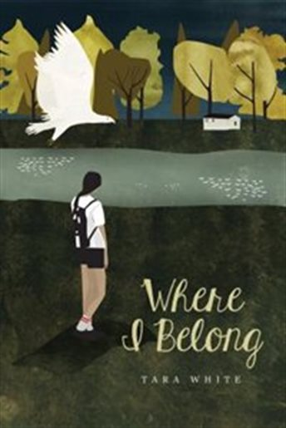 | 8-11 | Where I Belong by Tara White  Carrie is a young First Nations girl who was adopted as a baby. Her search to find her roots leads her to Kahnawake, Quebec during the Oka crisis. Ultimately, she learns to love and accepts both her families and develops a sense of belonging.
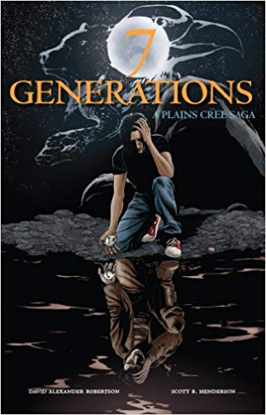 | 8-12  FR | 7 Generations: Plains Cree Saga by David Alexander Robertson  The 7 Generations series is available in one book, and the illustrations are in vivid colour. 7 Generations: A Plains Cree Saga includes the four graphic novels: Stone, Scars, Ends/Begins, and The Pact. Edwin is facing an uncertain future. Only by learning about his family's past--wars, the smallpox epidemic, a residential school--will he be able to face the present and embrace the future.
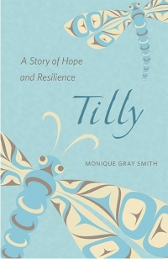 | 8-12 | Tilly: A Story of Hope and Resistance by Monique Grey Smith  Tilly has always known she’s part Lakota on her dad’s side. She’s grown up with the traditional teachings of her grandma, relishing the life lessons of her beloved mentor. But it isn’t until an angry man shouts something on the street that Tilly realizes her mom is Aboriginal, too—a Cree woman taken from her own parents as a baby.
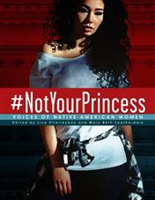 | 8-12 | Not Your Princess by Lisa Charleyboy  This collection of poetry, opinions, interviews, artworks, and photography expresses what it means to be a First Nations woman. Each piece is the realistic perspective of a young Indigenous woman and deals with complex issues Indigenous women had to, and often still have to, deal with including stereotyping, residential schools, missing Indigenous women, misogyny, and sexual abuse. The images complement, and help students connect to, the words and stories. The emotionally-charged content is suited to mature and sensitive senior English or First Nations classes, and lends itself to discussions, writing activities, and making connections between the modern stories and historical events.
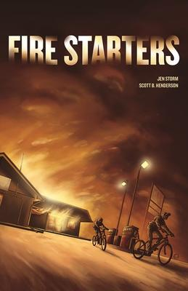 | 9-12 | Fire Starters by Jen Storm and Scott B. Henderson  When two indigenous youth find an old flare gun and decide to have some fun, they are accused by the sheriff’s son of setting a fire at the local gas station. As this graphic novel unfolds, the true culprit is discovered and the novel concludes with restorative justice for the offender. This engaging graphic novel, with appealing and dynamic visuals, examines the underlying prejudice of a small Canadian town. Suited as a class novel to launch discussion of issues of race, responsibility, doing the right thing, and restorative justice, it could equally work well for a literature circle or independent novel choice for grades 9-12.
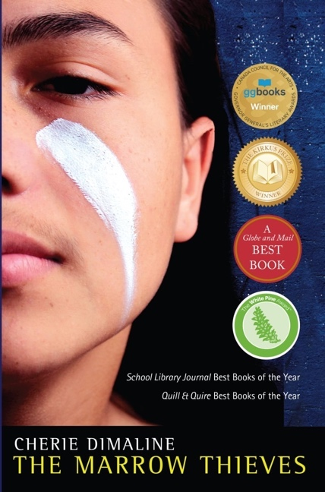 | 9-12 | Marrow Thieves by Cherie Dimaline  The future is plagued with global warming, wars, and chaos, and most humans can no longer dream – except for indigenous people. Scientists discover that if their bone marrow is extracted and injected into dreamless people their dreams will return, which leads to marrow extraction centres, similar to residential schools. Teenager Frenchie joins forces with other nomadic indigenous people to escape capture and in turn they learn about their history. This important Canadian novel, filled with rich detail and descriptive language, is suitable for grades 9-12, and deals with issues of identity, loss, family, residential schools, and destruction of culture and language. Social considerations are noted.  The future is plagued with global warming, wars, and chaos, and most humans can no longer dream – except for indigenous people. Scientists discover that if their bone marrow is extracted and injected into dreamless people their dreams will return, which leads to marrow extraction centres, similar to residential schools. Teenager Frenchie joins forces with other nomadic indigenous people to escape capture and in turn they learn about their history. This important Canadian novel, filled with rich detail and descriptive language, is suitable for grades 9-12, and deals with issues of identity, loss, family, residential schools, and destruction of culture and language. Social considerations are noted.  Lesson ideas:  https://novelalliances.com/2019/10/01/the-marrow-thieves-strategic-plan-assignment/  https://www.smore.com/kgmht-the-marrow-thieves
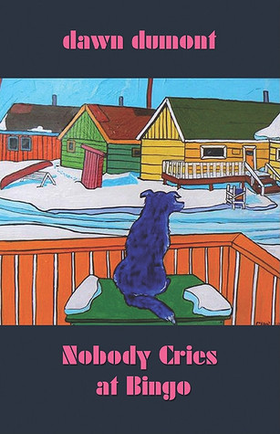 | 9-12 | Nobody Cries at Bingo by Dawn Dumont  In Nobody Cries At Bingo the narrator, Dawn, invites the reader to witness firsthand Dumont family life on the Okanese First Nation. Beyond the stereotypes and cliche's of Rez dogs, drinking, and bingos, the story of a girl who loved to read and her family begins to unfold.
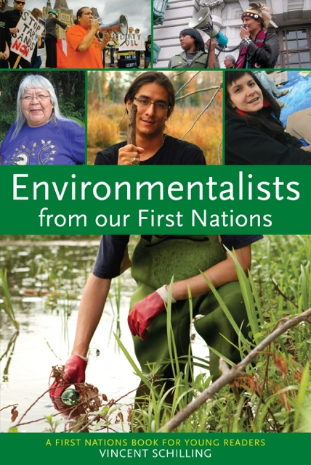 | 9-12 | From Our First Nations  This resource is a collection of biographies of First Nations people from all over North America who are demonstrating passion and change as they defend their traditional lands and environment.
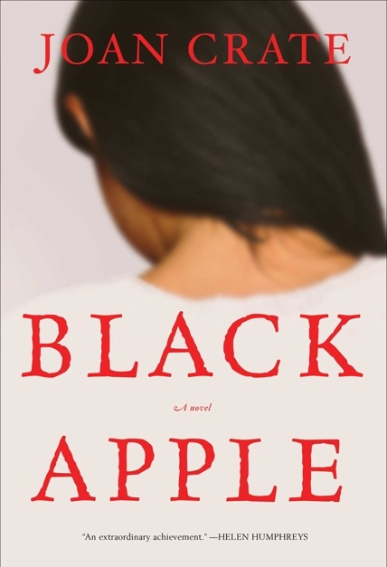 | 9-12 | Black Apple by Joan Crate  Sinopaki is taken from her home and family and sent to a Residential School run by nuns who are determined to ‘save’ First Nations students from eternal damnation. Her journey from a scared young girl through to a young woman struggling to find her identity and questioning whether she can return to her First Nations roots or should stay at the school provides a glimpse of the difficulties First Nations peoples had trying to reconcile their heritage with their Western education. Suitable for grades 9-12, the novel could be used in a literature circle and to foster discussion of residential schools, coming of age, identity, and the journey to adulthood. Social considerations noted.
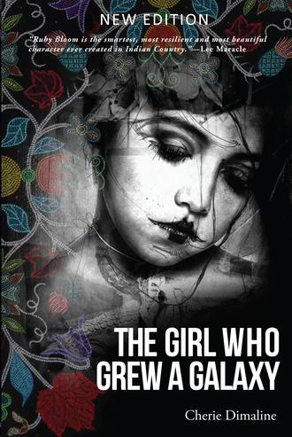 | 10-12 | The Girl Who Grew a Galaxy by Cherie Dimaline  A galaxy of odd planets spins around Ruby Bloom’s head, slick and regulated as a game of snooker.  The big purple one is Anxiety. It grew in the slipstream of Guilt, a smooth, loud planet with two moons: Obsessive Compulsive Disorder and Agoraphobia. The black one is Envy. It’s crusted with ice and solid as tungsten. The pink spotted one, a loud sparkly affair, is Fantasy and it careens wildly about like a ball after the break. There is a shiny amber globe that catches passing light; a small marble named Longing that is the brightest of all the orbs.  The universe didn’t start with a big bang of cosmic proportions; instead it grew out of trauma that occurred in the middle of an otherwise quiet childhood. It began the day Ruby Bloom, age seven and a half, killed her grandfather.
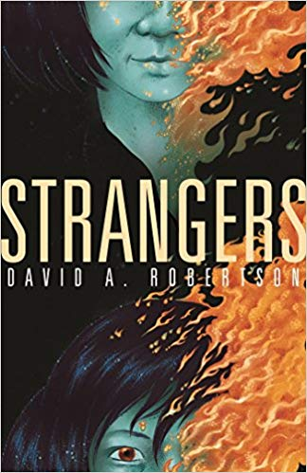 | 10-12 | Strangers by David Alexander Robertson  Cole has not visited his home—Wounded Sky First Nation—for a decade, but when a “friend” implores him to visit he relents. His return is greeted with suspicion and derision by many, especially when mysterious events, including death and disease, follow him wherever he goes. A past encounter with the trickster Coyote gave him special powers, but can he use them to save his community? This engaging novel combines Indigenous ideas and teachings with suspenseful adventure and can launch discussions, research, and critical, creative, and reflective thinking. Useful as a read-aloud, class, lit circle, book club, or independent read.  First of a trilogy
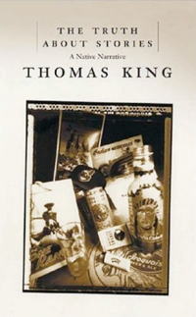 | 10-12 | The Truth about Stories: A Native Narrative  by Thomas King  Beginning with a traditional oral story, King weaves his way through literature and history, religion and politics, popular culture and social protest, gracefully elucidating North America’s relationship with its Indigenous peoples. Also a Massey Lecture Series (audio available).
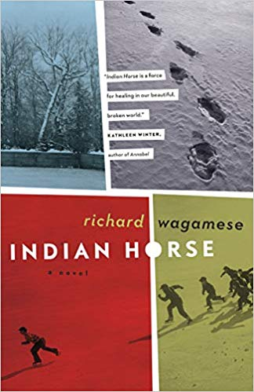 | 10 - Adult | Indian Horse by Richard Wagamese  Saul Indian Horse has hit bottom. His last binge almost killed him and now he's a reluctant resident in a treatment centre. But Saul wants peace and he realizes that he'll only find it through telling his story. Beginning with his childhood on the land, he embarks on a journey through his life as a northern Ojibway, with all its joys and sorrows.  For Saul, taken forcibly from the land and his family when he’s sent to residential school, salvation comes fror a while through his incredible gifts as a hockey player. But in the harsh realities of 1960s Canada, he battles racism and the spirit-destroying effects of cultural alienation and displacement.
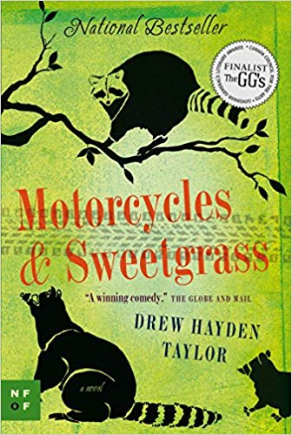 | 11- Adult | Motorcycles & Sweetgrass: A Novel by Drew Hayden Taylor  A story of magic, family, a mysterious stranger . . . and a band of marauding raccoons.  Otter Lake is a sleepy Anishnawbe community where little happens. Until the day a handsome stranger pulls up astride a 1953 Indian Chief motorcycle – and turns Otter Lake completely upside-down Maggie, the Reserve’s chief, is swept off her feet, but Virgil, her teenage son, is less than enchanted. Suspicious of the stranger’s intentions, he teams up with his uncle Wayne – a master of aboriginal martial arts – to drive the stranger from the Reserve. And it turns out that the raccoons are willing to lend a hand.
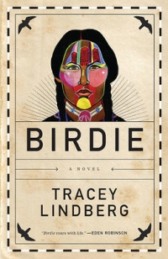 | 12-Adult | Birdie by Tracy Lindberg  Birdie is a darkly comic and moving first novel about the universal experience of recovering from wounds of the past, informed by the lore and knowledge of Cree traditions. Bernice Meetoos, a Cree woman, leaves her home in Northern Alberta following tragedy and travels to Gibsons, BC. She is on something of a vision quest, seeking to understand the messages from The Frugal Gourmet (one of the only television shows available on CBC North) that come to her in her dreams. She is also driven by the leftover teenaged desire to meet Pat Johns, who played Jesse on The Beachcombers, because he is, as she says, a working, healthy Indian man. Bernice heads for Molly’s Reach to find answers but they are not the ones she expected.  Pre-read  Lesson ideas: https://www.traceylindberg.ca/images/tl/books/FINAL_July20_2017_BIRDIE_TeachersGuide.pdf

