Short Story Collections

COVER | GRADE | TITLE/INFO
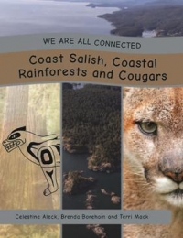 | K-12 | We are all Connected Series  We Are All Connected is a series that explores how we all live together in a shared balance upon Mother Earth. Each book explores a specific ecosystem with a focus on one animal and its adaptations for survival within that ecosystem. Indigenous interviewees, each living within the same area, have responded to strategic questions as to how their community interacts with the land, their traditional territory. Explore each text with a sense of inquiry in mind.
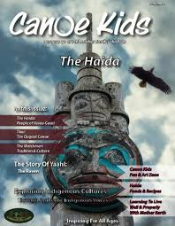 | K-12 | Canoe Kids  This Canadian magazine-style resource has a number of illustrated short articles providing historical, environmental, and cultural information about the Haida Nation. Suitable for grades K-12, it offers many uses in the classroom: articles could promote discussion and prompt journal writing, images and personal narratives provide a starting point for inquiry-based learning, and its culturally rich stories, history, and imagery make it a useful supplementary resource. The resource offers book reviews, an accompanying online resource, and movie and documentary suggestions that could be used for higher-level, critical thinking discussions and activities. Volume 2 of a 24 volume series
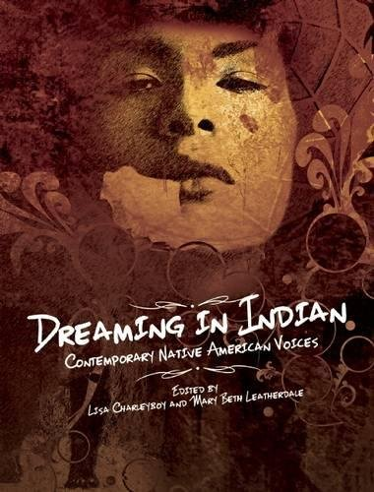 | K-11 | Dreaming in Indian  By Lisa Charleyboy  This is a highly engaging, visually rich and representative sample of Aboriginal voice from all over North America. It is an excellent fit with the expectation that aboriginal perspectives be integrated into the curriculum
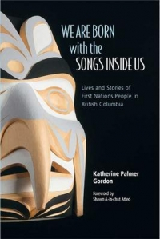 | 2-12 | We are born with the songs inside us: lives and stories of First Nations people in British Columbia  By Katherine Palmer Gordon.  Since 2004, journalist Katherine Palmer Gordon has interviewed dozens of inspirational young First Nations people living in British Columbia - artists and community leaders, comedians and consultants, musicians and lawyers, people who are household names and those known only within their own communities. This book collects sixteen candid stories gleaned from those interviews - stories of people who share an unshakeable belief in the importance of their cultural heritage to their well-being, to their success at what they do, and to their everyday lives.
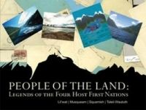 | 4-12 | People of the Land Legends from our Four Host Nations  The sacred legends of the four host First Nations, the Lil’wat, Musqueam, Squamish, and Tsleil-Waututh, have been passed down from generation to generation through the Elders and are integral to the teachings and oral traditions of First Nations peoples. These stories link people to the land and to each other.
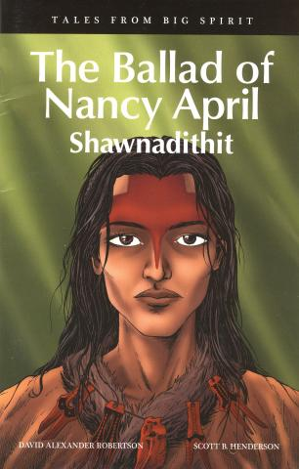 | GN  4-12  FR | Tales from Big Spirit  By David Alexander Robertson ad Scott Henderson  A unique six-book graphic novel series that delves into the stories of six great Indigenous heroes from Aboriginal peoples and Canadian history—some already well known and others who deserve to be. Designed to correspond to grades 4–6 social studies curriculums across Canada, these full colour graphic novels could be used in literature circles, novel studies, and book clubs to facilitate discussion of social studies topics.
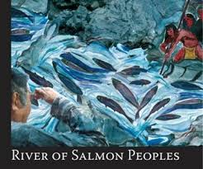 | 6-12 | River of Salmon Peoples  The product of a multi-year project to gather information about Indigenous communities’ relationship with the Fraser River and the importance of salmon to the communities, it includes verbatim transcripts of focus groups that met to share stories and provide testimony. The various formats in the book, including story, art, photos, narratives, and memoirs, are suitable for a range of learning and teaching styles. Suitable for grades 6-12, this timely resource is visually stunning with coloured photos and art images, and can be used to extend learning through projects/inquiry and to review the impact of resource development on salmon stocks and government management policies.
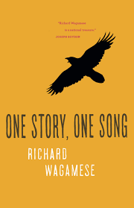 | 7-12 | One Story, One Song  By Richard Wagamese  This autobiographical work, by Canadian Indigenous author Richard Wagamese, is a collection of vignettes reflecting his life lessons, messages, and values. The stories provide lessons of hope, humility, strength, grit, and resilience, and he invites readers to contemplate their interactions and interconnectedness with people, animals, and the Earth. This work, for grades 7-12, sheds light on situations that will help students develop greater understanding and empathy for others. Written using clear and common language, it could be a useful novel study or for a class read while discussing or responding to the topics and teachings found in each chapter.
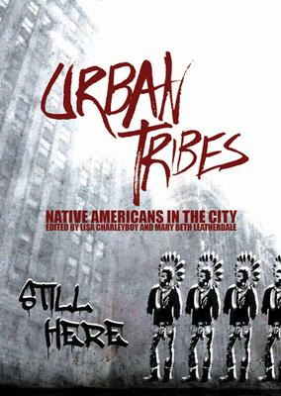 | 7-12 | Urban Tribes: Native Americans in the City  By Lisa Charleyboy  Urban Tribes offers unique insigt into this growing and often misperceived group. This anthology profiles young urban Natives and how they connect with Native culture and values in their contemporary lives.  Their stories are as diverse as they are. From a young Dene woman pursuing an MBA at Stanford University to a Pima photographer in Phoenix to a Mohawk actress in New York City, these urban Natives share their unique insight to bridge the divide between their past and their future, their cultural home and their adopted cities.
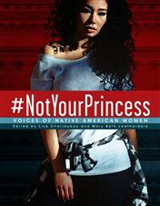 | 8-12 | Not Your Princess  By Lisa Charleyboy  This collection of poetry, opinions, interviews, artworks, and photography expresses what it means to be a First Nations woman. Each piece is the realistic perspective of a young Indigenous woman and deals with complex issues Indigenous women had to, and often still have to, deal with including stereotyping, residential schools, missing Indigenous women, misogyny, and sexual abuse. The images complement, and help students connect to, the words and stories. The emotionally-charged content is suited to mature and sensitive senior English or First Nations classes, and lends itself to discussions, writing activities, and making connections between the modern stories and historical events.
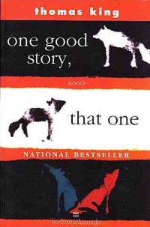 | 8-12 | One good story, that one: Stories  By Thomas King  Inspired by the native oral tradition, this book opens with a clever creation tale introducing the traditional native wily coyote. King blends native historical realities with contemporary life in an amusing parody of the biblical Garden of Eden story. Powerful characters, sharp dialogue and profound insights make this an unforgettable read
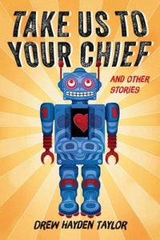 | 8-12 | Take us to your chief and other stories  by Drew Hayden Taylor  The nine stories in this collection span all traditional topics of science fiction – from peaceful aliens to hostile invaders; from space travel to time travel; from government conspiracies to connections across generation. Taylor’s First Nations perspective draws fresh parallels, likening the cultural implications of alien contact to those of the arrival of Europeans in the Americas, or highlighting the impossibility of remaining a “good Native” in such an unnatural situation as a space mission.
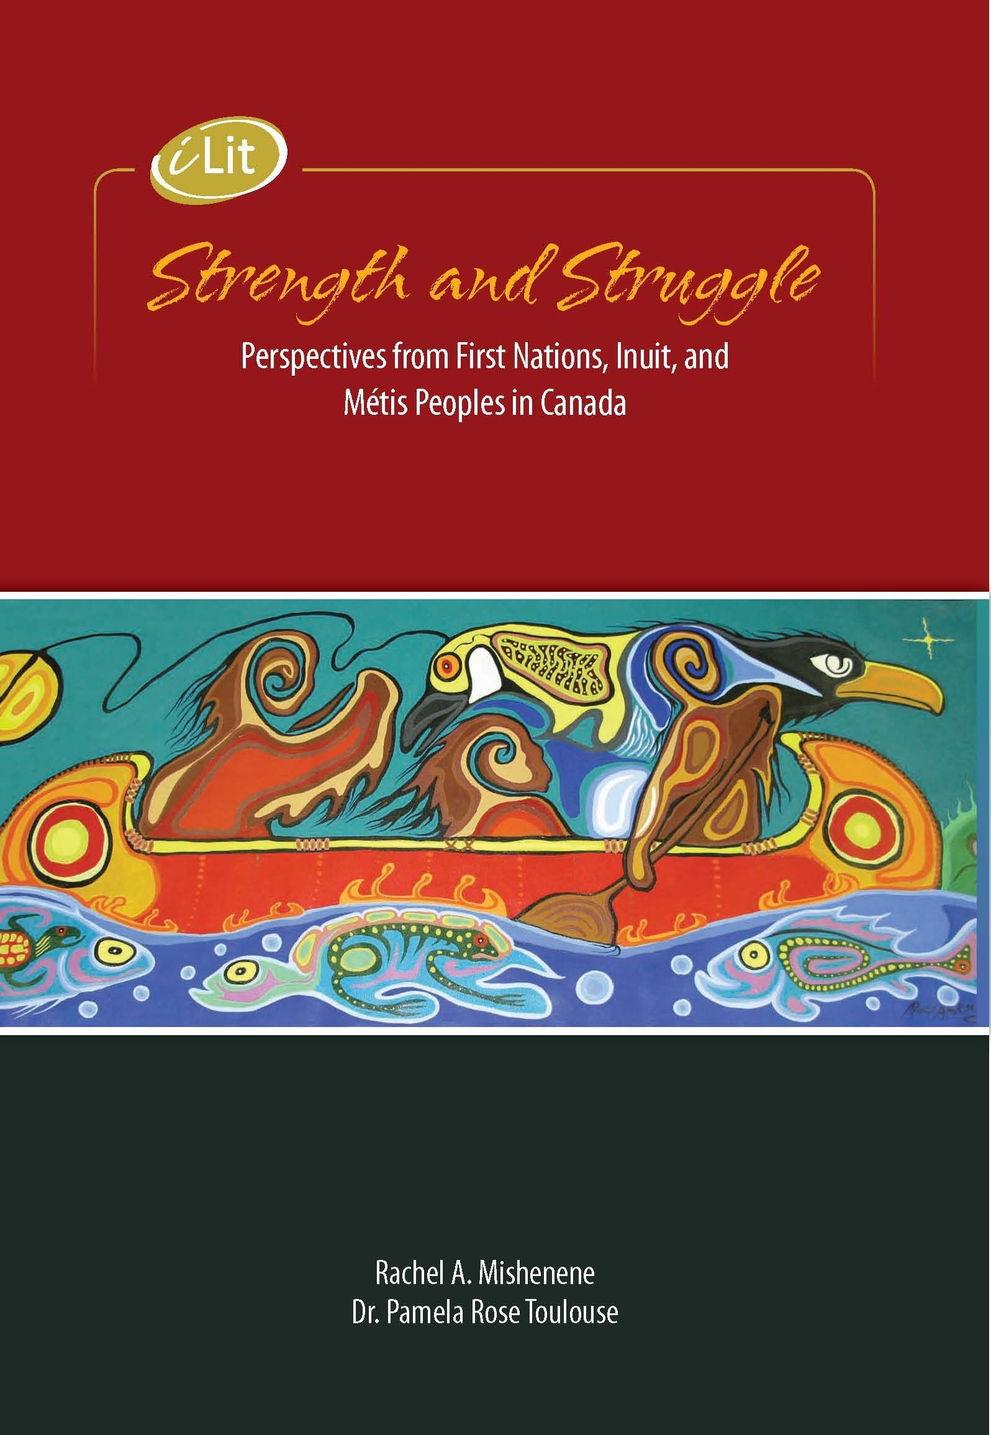 | 8-12 | Strength and Struggle: Perspectives from First Nations, Inuit, and Metis Peoples in Canada.  by Rachel A. Mishenene  a rich array of graphic novel panels, speech excerpts, song and rap lyrics, recipes, interview, short stories, poetry, photographs, graphic art, articles, essays, and other pieces that will have you laughing, crying, talking, and thinking. It's a true celebration of First Nations, Inuit, and Métis writing and art.
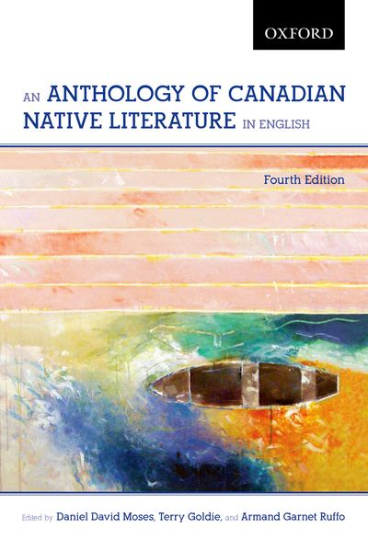 | 10-12 | An Anthology of Canadian Native Literature in English  By Daniel David Moses  This collection presents writing in English by Canadian Native authors featuring prose selections, traditional songs, short stories, plays, poems and essays, showing a complexity and rich wealth of this culture.
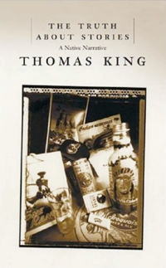 | 10-12 | The Truth about Stories: A Native Narrative  by Thomas King  Beginning with a traditional oral story, King weaves his way through literature and history, religion and politics, popular culture and social protest, gracefully elucidating North America’s relationship with its Indigenous peoples. Also a Massey Lecture Series (audio available).
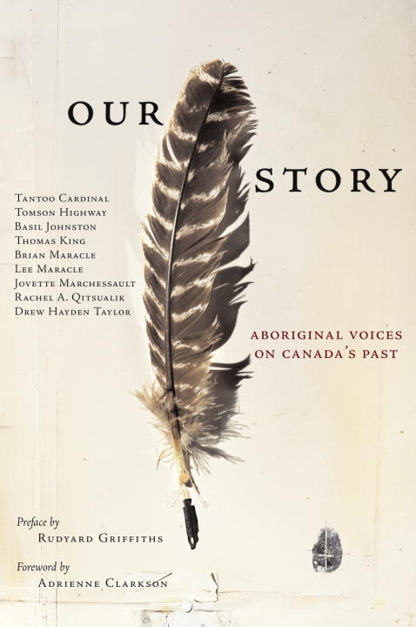 | 10 - Adult | Our Story: Aboriginal Voices on Canada’s Past  A collection of original stories written by some of the country’s most celebrated Aboriginal writers, and inspired by pivotal events in the country’s history. Ten acclaimed authors have travelled through our country’s past to discover the moments that shaped our nation and its people.
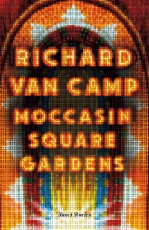 | 11 - Adult | Moccasin Square Gardens: Short Stories  By Richard Van Camp  The characters of Moccasin Square Gardens inhabit Denendeh, the land of the people north of the sixtieth parallel. These stories are filled with in-laws, outlaws, and common-laws. This hilarious short story collection is also haunted by the lurking presence of the Wheetago, human-devouring monsters of legend that have returned due to global warming and the greed of humanity. The stories in Moccasin Square Gardens show that medicine power always comes with a price.

