Coast Salish Weaving – Grades 3/4

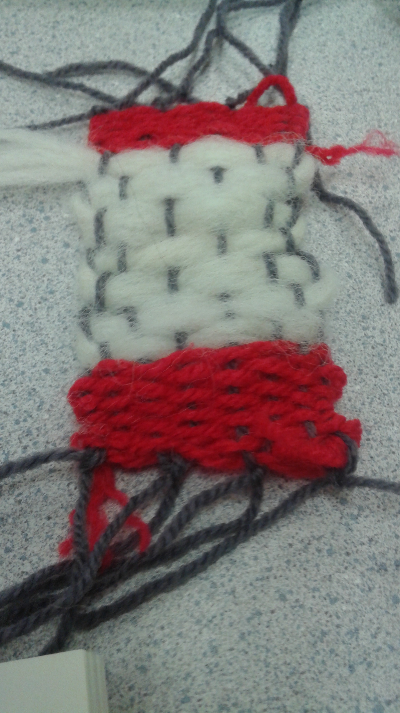

Weaving Math Lessons for Grade 3 and 4
Three lessons

Learning Standards:
Curricular Competencies
- Model math in contextualized experiences
- Use Technology to explore mathematics

Curricular Content:
- Using non-standard measuring units
- Changes in patterns can be represented in charts, and graphs
Materials
- Samples of Coast Salish Weaving (blanket showing shapes – or photo)
- Two large quarter bag samples (showing pattern - photo)
- Graphing paper (for lesson 1)
- Expanding pattern sheets (for lesson 2)
- Cardboard looms (for lesson 3)
- Wool or yarn, rulers (for lesson 3)

Lesson One:
Students will be given a samples of Coast Salish weaving. (See photos of samples). Thinking like a Coast Salish weaver, students are going to explore what it takes to be a weaver. Can they see math in weaving? After exploring samples, students will design their own weaving on graph paper.

Discussion:
- What shapes to do you see? Can you name them? Do some of the shapes have similar attributes? Can you see patterns in the sample? What kind of patterns? Are there expanding or repeated patterns? How were the patterns made?
- How do you think this blanket was made? Talk about looms/weaving/warps/wefts
- How do you think Coast Salish weavers made patterns in their weaving?

Show samples of loom (cardboard loom or real) – talk about the warp, weft, and loom
- Talk about how rows of weaving are made. What kind of materials do you think Coast Salish weavers used? Show picture of wooly dog, mountain goat … (see photos attached). What kind of resources do you think contemporary weavers use today?

Activity:
- Ask students to replicate one of the pieces of Coast Salish art using graphing paper. Students may also choose to design their own pattern. They must label their replica (warp, loom weft). Their design must have a pattern and feature at least one geometric shape.
- Challenge activity – expanding worksheets.

Sample graphs from students:

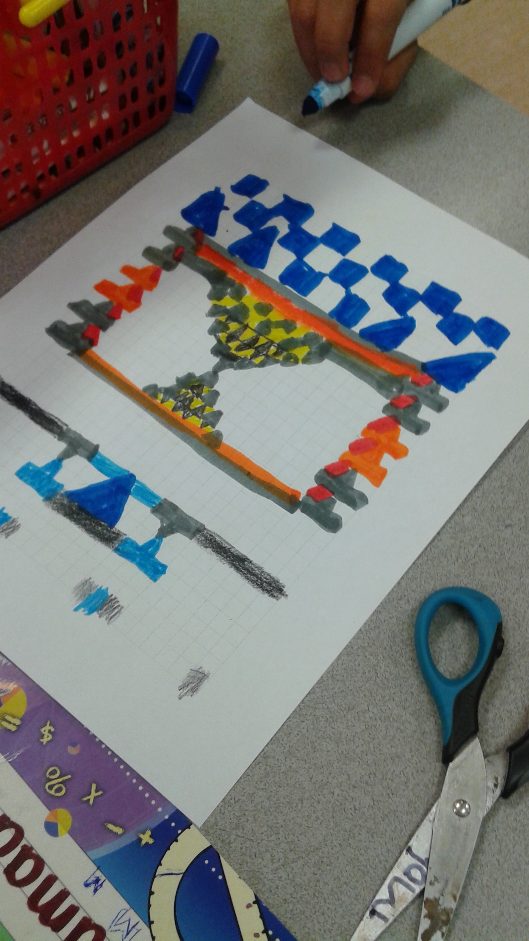

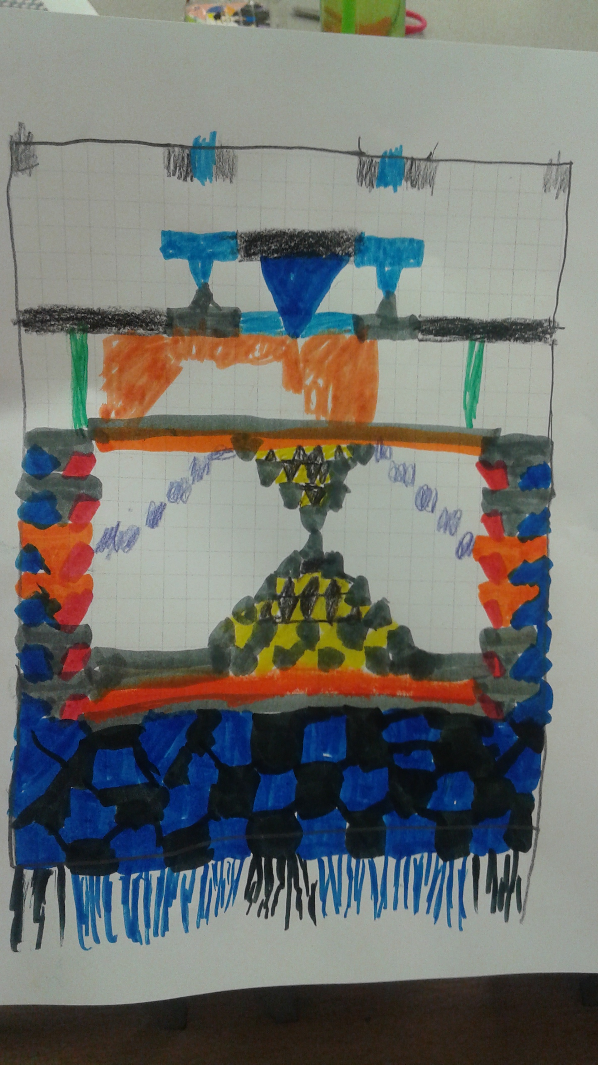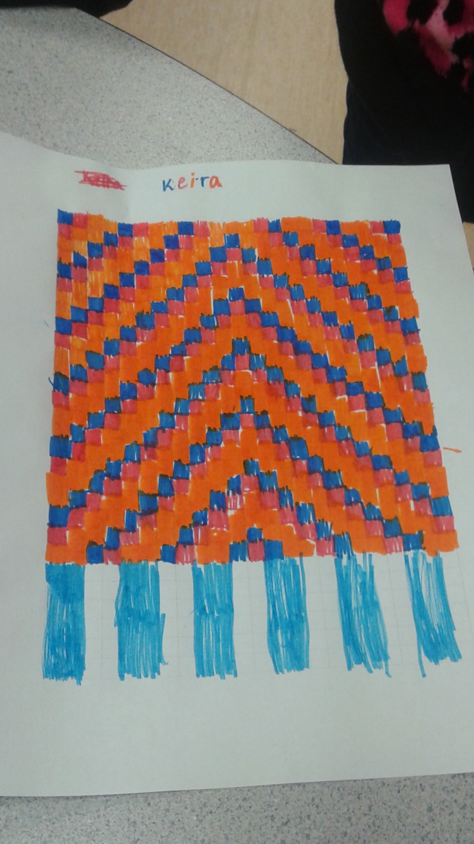

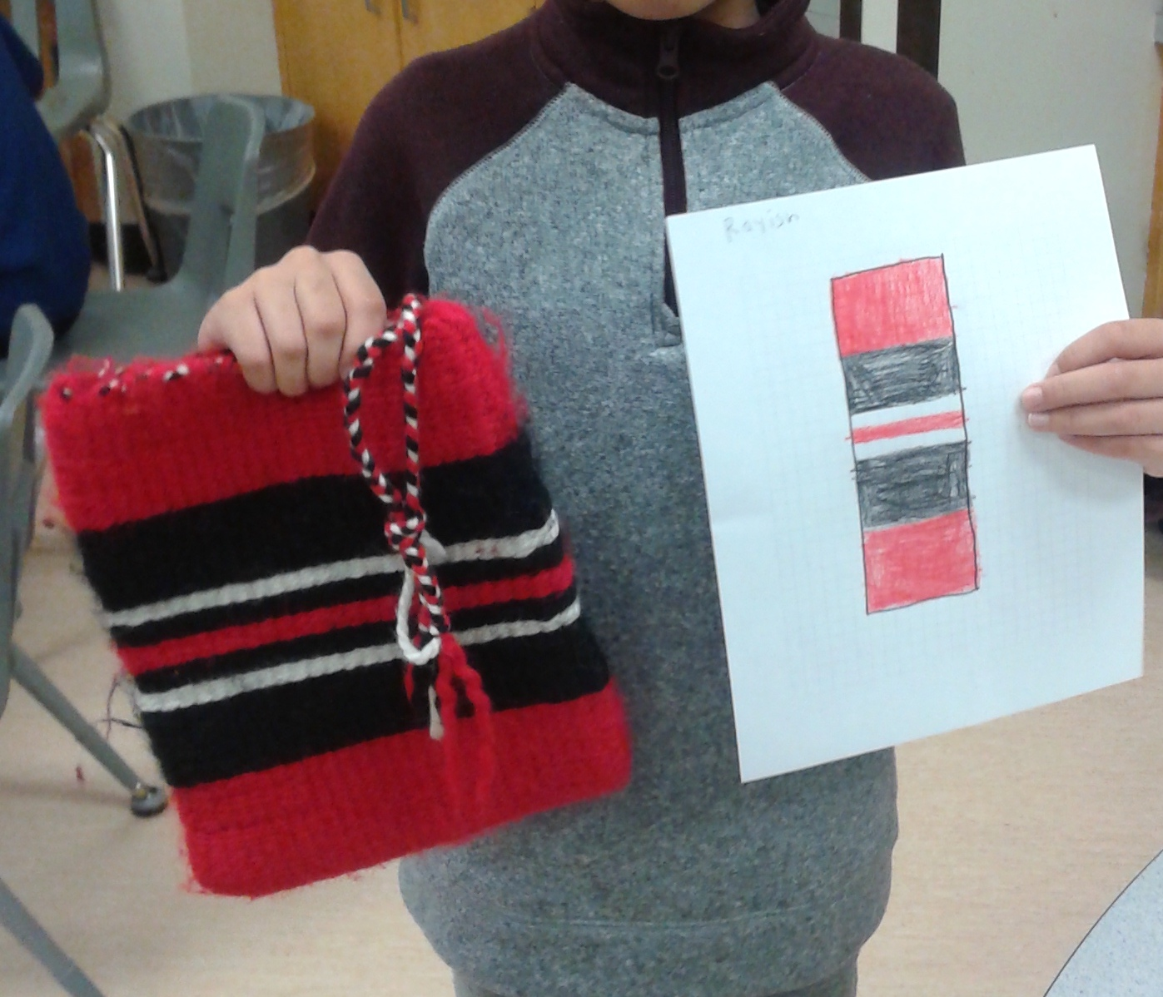

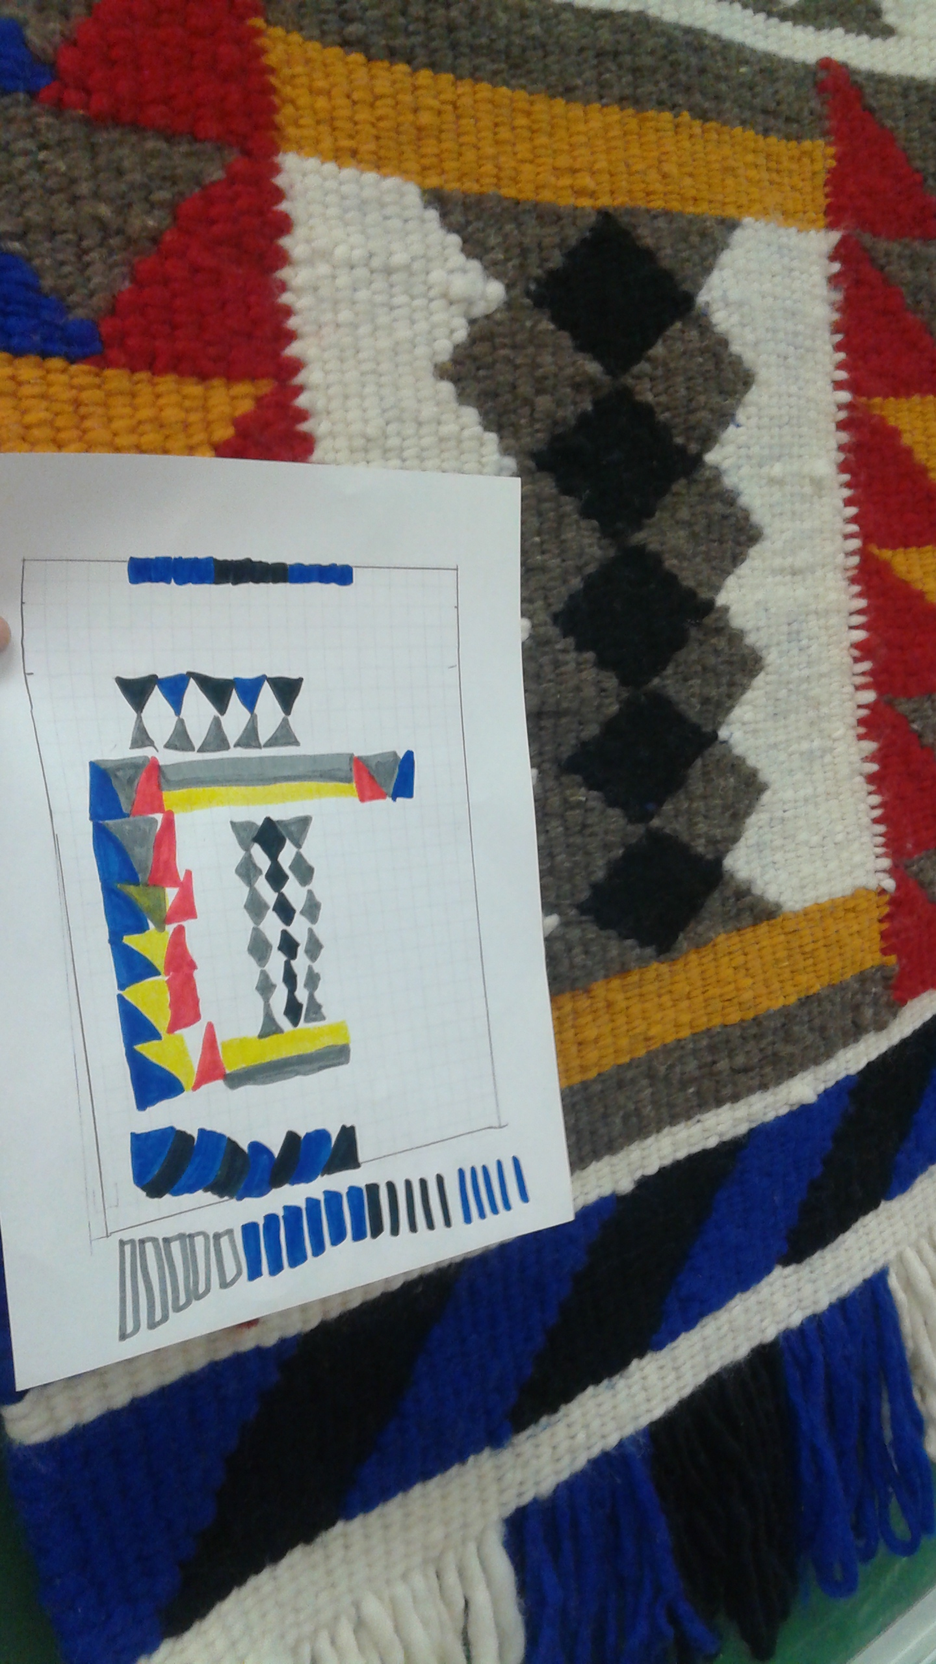

Lesson Two:

Students will use measurement and non-standard units to explore Coast Salish Weaving. Looking at our samples, try and determine the number of rows it takes to make 5 cm of weaving.

Discussion:
- What resources would have been available to Coast Salish weavers? Most blankets today are made from wool. Traditionally, they would have been made from wool from the wooly dog, mountain goat and cedar.
- How do you think Coast Salish weavers planned their blankets designs? What do you think is represented in their designs? What materials would they have had access to dye wool? These last two questions make connections to the land and resources on it. In many Coast Salish designed, you’ll see evidence of land features (water, mountains), and reflections of animals (bird formations – flying geese formation). Ask students to think about what features they would want to include in a weaving they designed. Think of Surrey. Think about land features/animals/plants they might want featured in their weaving.

Students are given samples of Coast Salish weaving that they’ve seen the previous day. Today, they are going to explore measurements.
- Look at the sample weaving. How many rows do you think it took to make this blanket? What are some of the factors that would determine the number of rows? (hopefully students will think about the thickness of the wool, the individual weaver – tension used in weaving,
- Let’s look at the warp of the loom. What difference does it make if we have 10 strands of warp on our loom, or 20 strands?

Activity
- Set up four stations one each with a weaving sample. Use samples that use different thicknesses of wool – different tensions. Students count the number of rows it takes to make 5 cm of weaving.

- Station 1- Grey bag
- Station 2 - Red and black bag
- Station 3 – blanket sample
- Station 4 – blanket sample 2

Lesson 3
Trying It Out – Weaving on A Cardboard Loom

In this lesson, students make their own weaving sample. I prepped the cardboard loom for them but grade 4 students could easily make their own loom. Instructions follow key teaching points.

Key teaching points in this lesson:
- Learning takes patience and time. This is a FPPL and relates directly to this lesson because students are learning a new skill. Talk to students about what it takes to learn a new skill. Are you good at it the first time you do it? How do you get better?
Talk about taking a break when you get frustrated. Put it down, take a little breathing break and take a moment to watch a friend. Taking the break is important and ties into the second key point.
- A protocol in FN culture is to give away something you make for the first time. Generally, we give it to an elder or someone who has taught us something.
We do this to honour people (particularly elders) who do good things for us. Ask students to think about who they might give their weaving to. Who is someone special to them who has taught them something?
Ask students to think about how hard it is to give away something you made for the first time. Ask them why FN people do this? It is a way of developing skills. If you give away your first weaving, and you really want one for yourself, you are likely going to make another. In this way, you develop your weaving skills.
Let students know that another FN belief is that when we are making something for somebody else, it is important to have a good heart. Keep that person in mind when you are making it. If you start to get frustrated because it feels too hard, put your weaving down and take a break. Focus on the person you are going to give your weaving too.
- Another key point is helping students understand the skill involved in learning to weave. Get them to think about how long it might take to make a full-sized blanket. Ask them to think about all the steps involved before starting to weave. What would have been involved in collecting wool from natural sources. Have them explore how to spin and dye wool. Weavers today have many advantages in that they can purchase looms, prepared wool.

I cut cardboard into 9 cm by 15 cm. Make 8 cm markings (1 cm apart on top and bottom and make about 1 cm cut. See the following video to see how to make the cardboard loom. Always have an even number of warps. I used one colour for the loom – the video shows two colours to help students see the pattern (over, under, over, under).

Video that shows how to make your loom and how to weave/finish: https://www.youtube.com/watch?v=AWLIy-Um7_0

Another great video with audio:
https://www.youtube.com/watch?v=gN0XUV_G64I

One More video:
https://www.youtube.com/watch?v=UaMz6wdq_Tw

Always make sure you have an EVEN number of warp threads!

< ------------------- 9 cm -------------------------
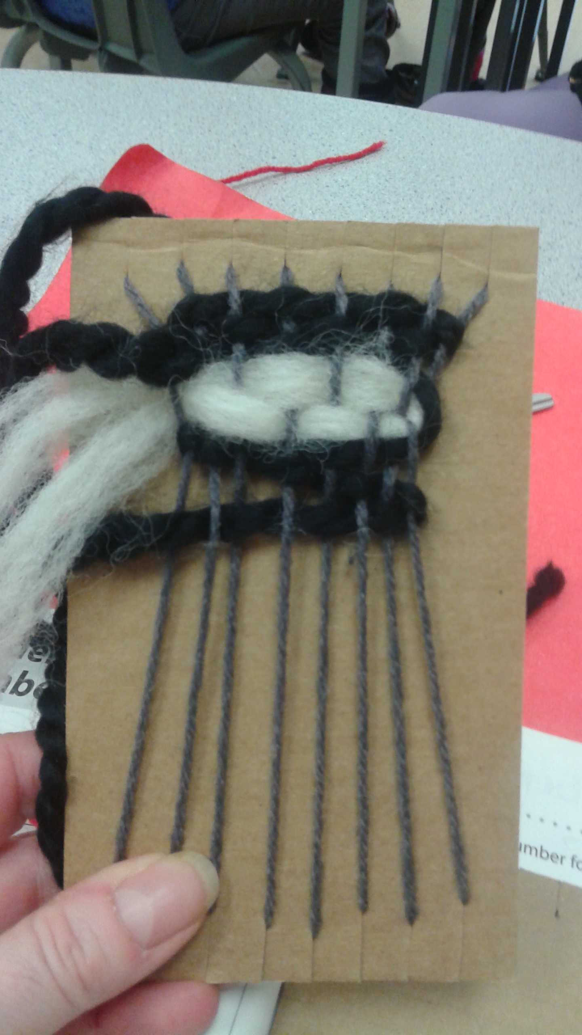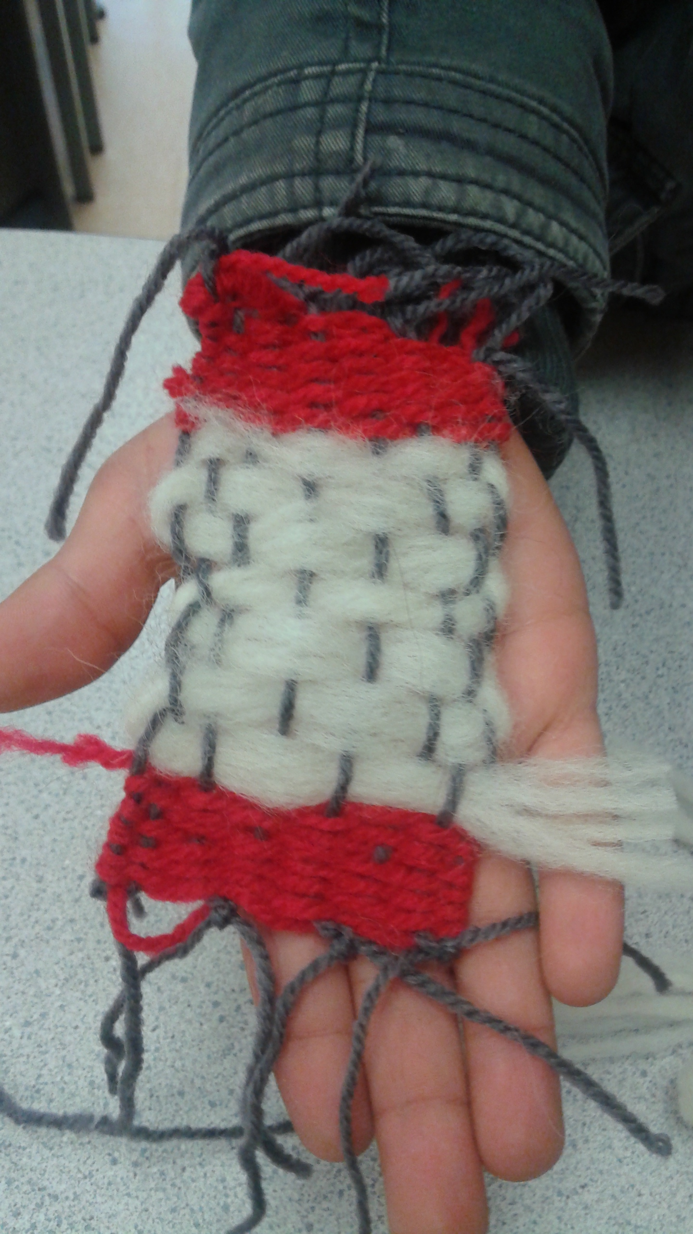

Debrief:
- Celebrate each weaving. Ask students to identify what they see in each of the weavings. Ask them to identify patterns, weaving tension and other unique characteristics in each weaving.
- Continually reinforce the notion that weaving is a skill. Skills are developed over time.
- Some students will excel at this. Use those students to support others.
- Finally, congratulate all students for trying something new. Talk about what they learned. Get them to identify and describe key vocabulary in these lessons (warp, weft, loom, patterns, tension)

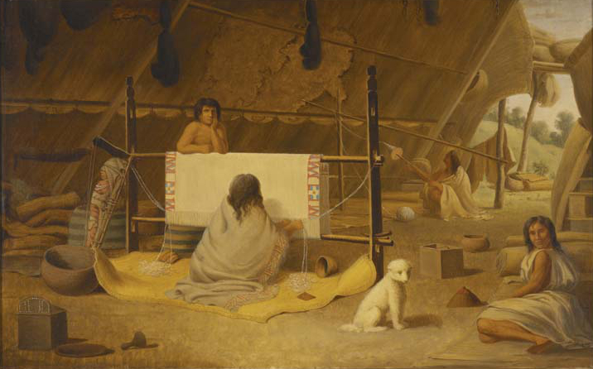
Wooly Dog –now extinct

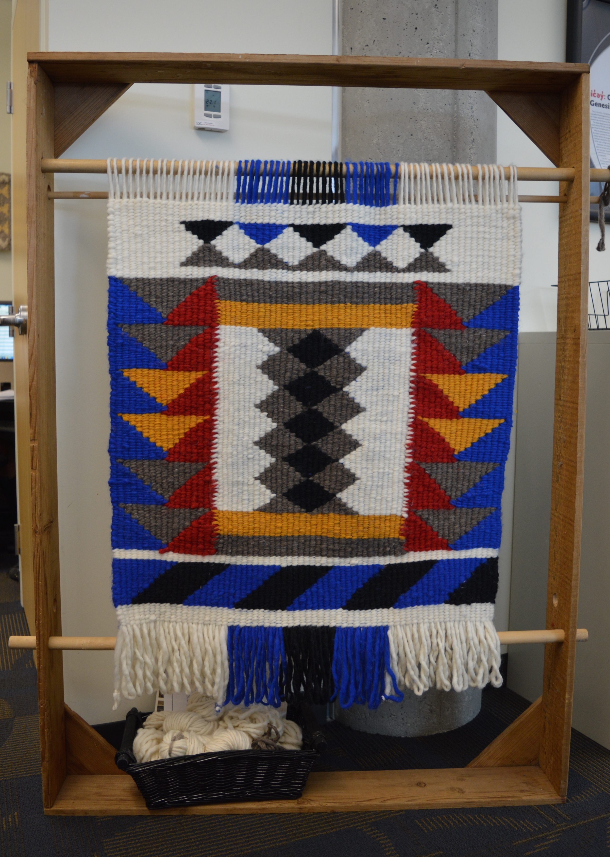
Graphing Sample

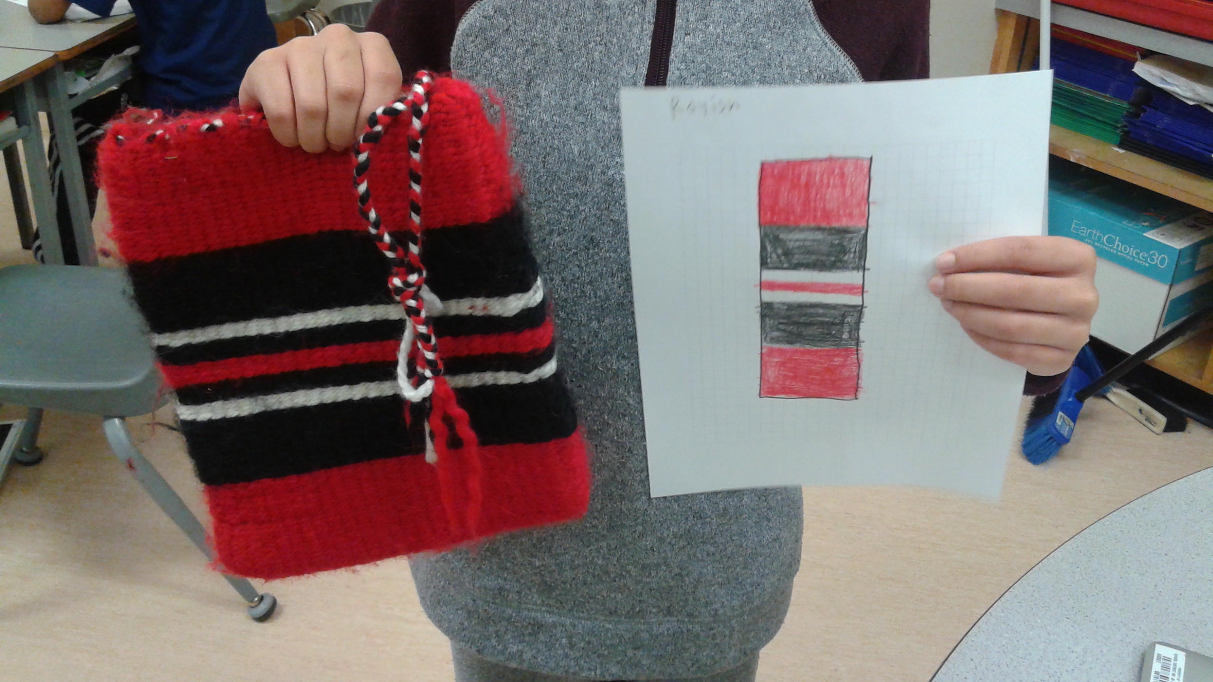

Graphing Sample 2

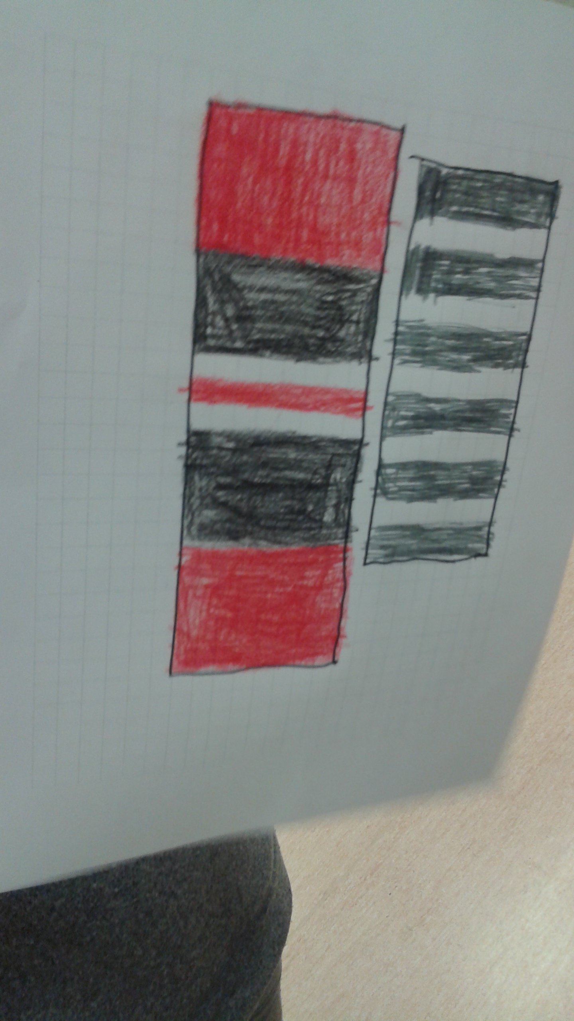

graphing sample 3 graphing sample 4

graphing sample 5 graphing sample 6

